Exploratory Variables and Suggested Analyses
1. Demographic Variables
- Variables:
  - age, gender, raceethnicity

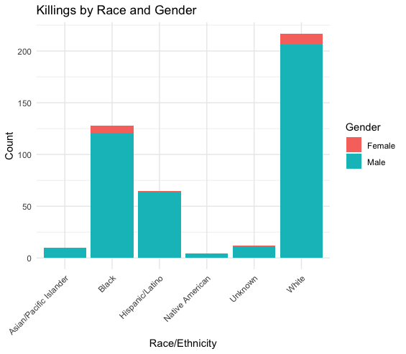
The chart displays a stark disparity in killings based on race and gender. Notably, Black individuals, particularly males, experience a disproportionately high number of killings compared to other racial and ethnic groups. This underscores the deeply rooted issue of systemic racism and violence within society.

2. Geographic Variables
- Variables:
  - latitude, longitude, state, city, county_id, killing_count
- Exploratory Questions:
  - Are there geographic hotspots for police killings?
  - Do certain states or cities have higher rates of incidents?
  - Are rural or urban counties more affected?
- Visualization Techniques:
  - Choropleth Map: Killings by state or county.

The map depicts the distribution of killings across the United States. It appears that the western states, particularly California and Texas, have significantly higher killing counts compared to the eastern states. This suggests potential regional disparities in factors contributing to violent crime, such as socioeconomic conditions, gun control laws, and cultural factors.

3. Temporal Variables
- Variables:
  - year, month, day, date
- Visualization Techniques:
  - Heatmap: Killings by day of the week and month.

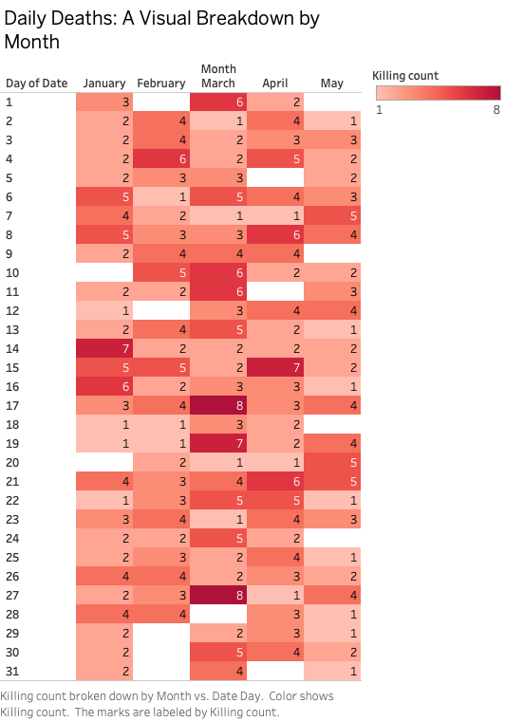

The heatmap effectively visualizes the distribution of daily deaths across different months. We can observe distinct patterns, such as higher death counts in certain months (like March) and specific days within those months. The color intensity corresponds to the severity of the death count, highlighting the most critical periods. However, without additional context or data labels, it's challenging to pinpoint the exact reasons behind these fluctuations.

4. Socioeconomic Variables
- Variables:
  - p_income, h_income, county_income, comp_income, pov, college
- Exploratory Questions:
  - Do areas with lower income or higher poverty see more killings?
  - Does education level impact the occurrence of incidents?
  - Are there income disparities between regions with police violence?
- Visualization Techniques:
- Per capita income vs. number of killings.

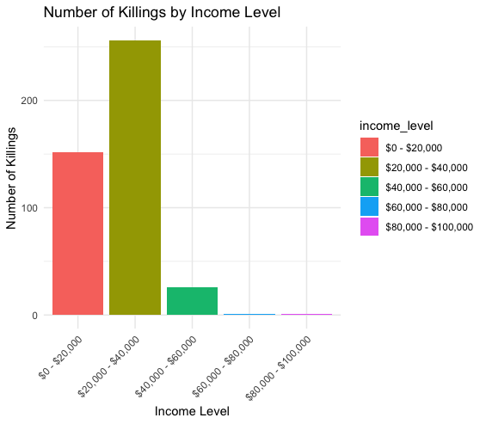

The bar chart effectively illustrates the relationship between income level and the number of killings. It's evident that lower-income groups experience a significantly higher number of killings compared to higher-income groups. This suggests a potential socioeconomic disparity in gun violence, with individuals in lower-income brackets being more vulnerable to violent crime. Further investigation is needed to understand the underlying factors contributing to this disparity, such as access to resources, education, and social support systems.

5. Intersectional Variables
- Variables:
  - raceethnicity, gender, age, armed, cause, income, latitude, longitude

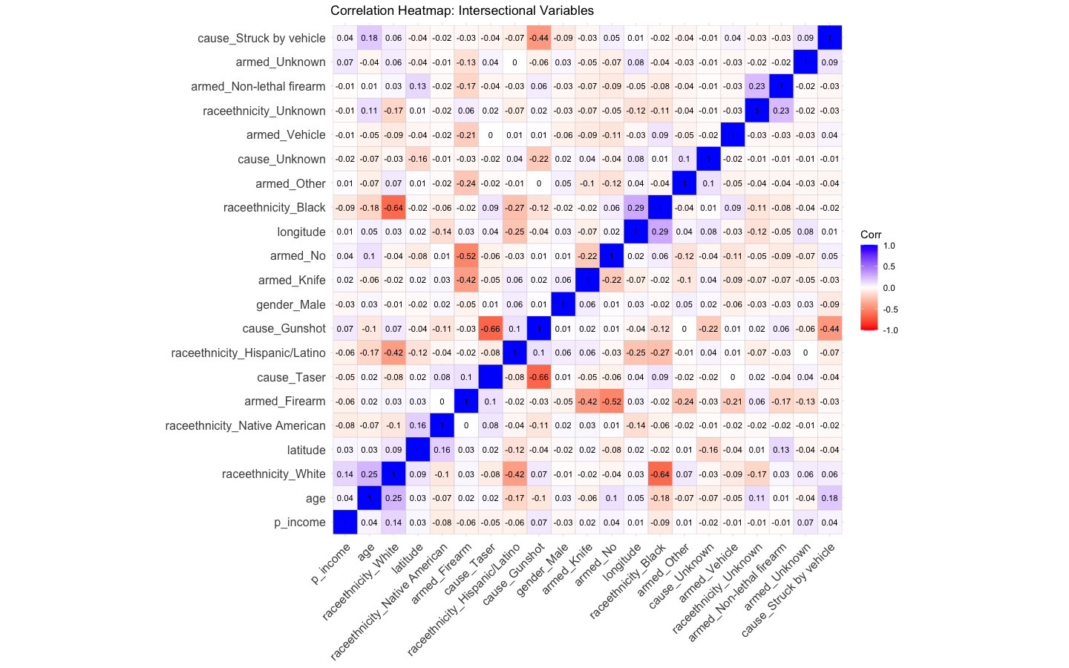

The correlation heatmap reveals several interesting patterns. Notably, there is a strong positive correlation between being armed with a firearm and being killed by a firearm. Additionally, race and ethnicity appear to play a significant role, with certain groups experiencing higher rates of both being armed and being killed. The heatmap also highlights potential correlations between geographic location and victim characteristics, suggesting that certain areas may have higher rates of gun violence. However, it's important to remember that correlation does not imply causation, and further analysis is needed to understand the underlying factors driving these relationships.

